TCE upgrade to Version 4.2.1

Dated December 29, 2012

What’s New?

The most important thing new in Version 4.2.1 is the addition of the new dental codes becoming effective as of January 1, 2013. Some insurance companies will be requiring use of the new codes immediately, and some won’t be able to accept them for some time afterward. You may choose to use either the old codes or the new as shown later in this document.

You may download the installer for this newest release of The Complete Exam® from our website at:

<http://www.TheCompleteexam.com/downloads>

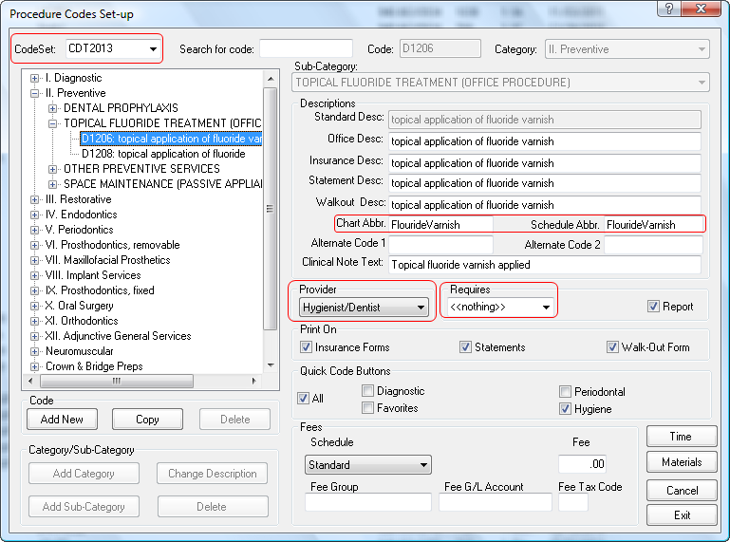**2013 Codes** After downloading the installer above and double-clicking on the downloaded file (tceupdate421.msi), you will be ready to start TCE with the new version. All users must be out of TCE when you do this since TCE will have to make some updates to the database structure. That will not be possible if anyone else is still using the previous version, so make sure no one else is running TCE when you first start the new version. The new version will install the new 2013 code list into the database, but it will not be automatically used. You will have to go into the *Settings - Procedure Code Set-up* area to select the 2013 Code Set. You can see that selection made at the top left of the screen shot below. There are several new codes that you will have to configure before they can be used. The Flouride Treatment codes are examples. At the right, you can see that the code D1206 has been selected for editing. Notice that D1203 and D1204 are no longer present. You must set the D1206 Chart and Schedule Abbreviations, shown by a red box drawn around them, to something no longer than 15 Characters. The default abbreviations you will see will not work since they are too long. You should also edit the Clinical Note text to suit your needs, set the provider choice to Hygienist/Dentist, and set the “Requires” choice to <<nothing>>. Also make sure that the Quick Code Buttons are appropriately checked. When you have the D1206 code set up the way you want it, click on the D1208 code in the listing at the left side of the screen to edit that code. Clicking a different code is the way to save your changes to the code you were just working on. You can verify that your changes were saved after clicking to the D1208 code by clicking back to the D1206 code. It should come up with the changes you just made. Now click back to the D1208 code to make the necessary changes to it. You should see the screen shown below.

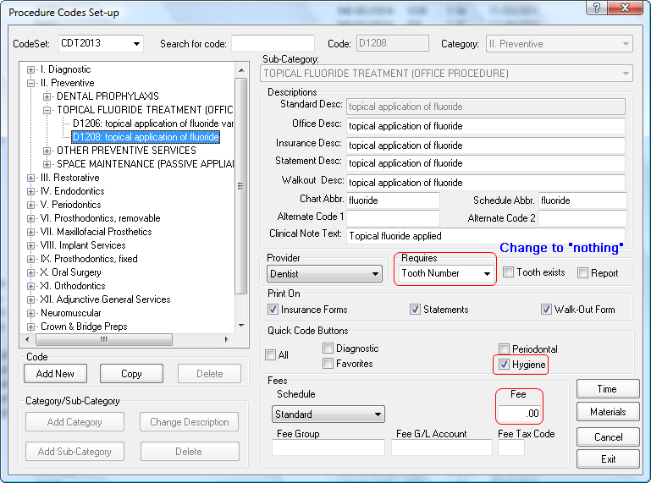

Since this is a new code, you will definitely have to make some changes to this setup. Edit the Clinical Note text if you want, and be sure to change the Provider choice from Dentist as shown above to Hygienist/Dentist. If you don’t, the Hygienist won’t be able to post this code as done by her. You should also change the Requires to “nothing” as indicated above so you don’t have to put in a tooth number every time you use this code. Be sure to check off the Quick Code buttons where you want this code to be listed, especially the “All” button, and enter a standard fee if you like. As before, when you have this code set up as you want, just click to another code, such as the D1206, to save these changes. Visit any other codes that are either new or modified in the new 2013 set and make any set up changes necessary before leaving the Procedure Code Set-up module. The ADA details all the additions, deletions, and changes from the 2011/2012 codes in their book of Common Dental Terminology for 2013.

**Images Tab Enhancements** Several people have asked for a way to group images to make it easier to find the one you want within a large number of mixed image types. In response to that request, we have set up filters for viewing your list of images saved in a patient’s chart by the types or categories you have classified them into. These image types are definable by you to suit your needs, and you may then sort or filter your images display to show only one or more types of your choice. You can see in the following screen shot that the six image types are shown next to check boxes that let you toggle on and off the specific types or categories of images you want to see at any time. The default view of the images tab shows no types selected to filter the listing, so TCE displays all of the images, regardless of type, just as it has always done. Since none of your images will have types assigned to them immediately after installing this upgrade, none of the filter boxes can be checked. Since checking any filter box will cause TCE to display only those images with that type assigned to them, you would see nothing if any boxes were check. Don’t check all six boxes if you want to see all your images because you would only see images that had their types set to one of those boxes. You would not see images that did not have a type assigned to them, which will be all of your existing images until you assign types to them. The image types shown in the following screen shots are the default names of the types we have as defaults.

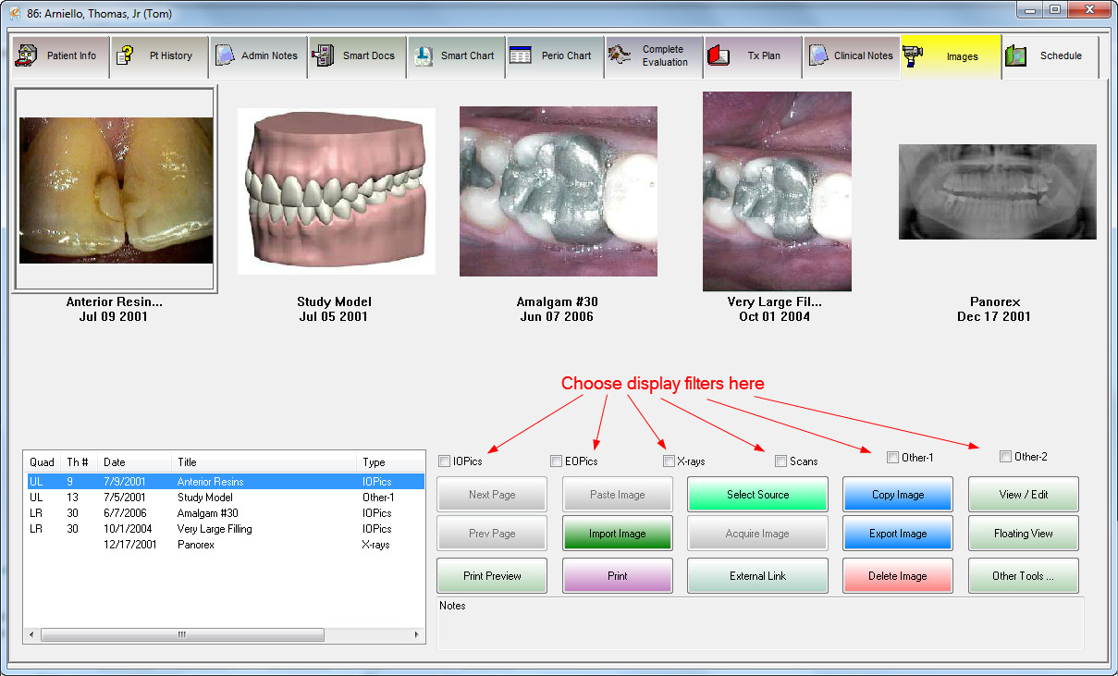

So how do you assign a type to an image? As you can see in the screen shot below, when you are either getting ready to save a newly taken image, or have an existing image selected for full sized viewing as below, you simply choose the type with the selector in the lowest left corner of the screen.

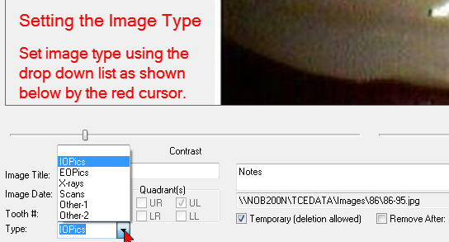

Now that you see how to actually use the filtering, how do you set up the names of the types to be what you want? From the menu bar, choose Settings – Practice Set Up – Image Storage Options as shown in the following screen shot.

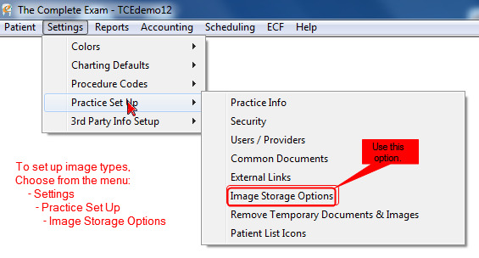

That brings up the setup screen shown below. In addition to specifying the storage location for your images as has always been possible from this screen, you will now see the names for the six image types. Shown below are the default image types. You can edit these to be whatever you like as long as the name fits in the field.

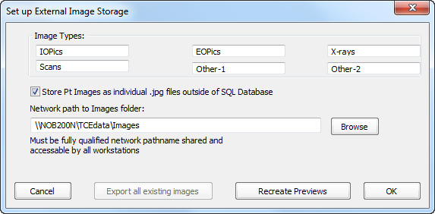

After you finish making any changes to the set up that you wish, just click on OK and you are all set to use the filters.

As you visit each patient’s chart the next time, you can click up each picture and assign an appropriate type to it if you wish. Then, continue to assign a type to each new image that you save. There is no harm in not going through and assigning an image type to everyone’s existing images if you don’t want to or don’t have the time. The images tab will work just as it always has since its default is to not have any filters selected and therefore show all images.

If you have any questions about any of these features of the new program version, or would like some help installing the upgrade, please feel free to give us a call at 866-THE EXAM or shoot us an e-mail at [support@TheCompleteExam.com](mailto:support@TheCompleteExam.com).